RETAIL PRICE OPTIMIZATION

A Project Report

In the partial fulfillment of the award of the degree of

B. Tech/MCA/BCA/BSc/Diploma

at

Ardent Computech Pvt. Ltd



Submitted by

[Name of the student (s)]

[College Logo]

[College Name]



Certificate from the Mentor

This is to certify that [Name of the student(s)] has completed the project titled [Project Name] under my supervision during the period from [Start Month] to [End Month] which is in partial fulfillment of requirements for the award of the B.Tech/MCA/BCA and submitted to Department [Department Name] of [College Name]

____________________
Signature of the Mentor

Date:

Acknowledgment

I take this opportunity to express my deep gratitude and sincerest thanks to my project mentor, [Name of the Mentor] for giving the most valuable suggestions, helpful guidance, and encouragement in the execution of this project work.

I would like to give a special mention to my colleagues. Last but not least I am grateful to all the faculty members of the Ardent Computech Pvt. Ltd. for their support.

Table of Contents

SERIOL NO. | TOPIC | PAGE NO.
1 | Company Profile | 01
2 | Introduction | 02
3 | Objective | 02
4 | System analysis | 03-07
4.1. | Identification of needs | 03
4.2. | Literature Review | 04
4.3. | Feasibility Study | 05
4.4. | Flow Diagram | 06
4.5. | System Architecture | 07
4.6. | Existing System | 07
4.7. | Drawbacks of Existing System | 8
4.8. | Proposed System | 9
4.9. | Proposed Methodology | 10
4.10. | Data Collection Details | 11
4.11. | Algorithm Used | 13
4.12. | Hardware and  Software Requirements | 14
5 | System design | 11
5.1. | Gantt chart | 11
5.2. | Pert Chart | 12
5.3. | Sequence diagram | 13
5.4. | Activity diagram | 14-15
5.5. | Snapshot | 16-18

6 | Implementation and Testing | 19-34
6.1 | Introduction | 19
6.2 | Objective ofTesting | 19
6.3 | Process Overview | 19
6.4 | Test Cases | 20
6.5 | Testing Step | 20
6.6 | Validation | 21-22
6.7 | White Box Testing | 23
6.8 | Black boxtesting | 23
6.9 | SystemTesting | 23
6.10 | Output Testing | 23
6.11 | User Acceptance Testing | 23
6.12 | Integration Testing | 24
6.13 | Functional Testing | 24
7 | System Security | 25
7.1 | Database Security | 25
7.2 | System Security | 25
7.3 | Limitation | 25
8 | Cost Estimation | 26-27
9 | Conclusion | 28
10 | Future scope and Future  Enhancement | 28

11 | Reference | 29

Company Profile

Ardent Computech Private Limited is an ISO 9001-2015 certified Software Development Company in India. It has been operating independently since 2003. It was recentlymerged with ARDENT TECHNOLOGIES.

Ardent Technologies

ARDENT TECHNOLOGIES is a Company successfully providing its services currently in UK, USA, Canada and India. The core line of activity at ARDENT TECHNOLOGIES is to develop customized application software covering the entire responsibility of performing the initial system study, design, development, implementation and training. It also deals with consultancy services and Electronic Security systems. Its primary clientele includes educational institutes, entertainment industries, resorts, theme parks, service industry, telecom operators, media and other business houses working in various capacities.

Ardent Collaborations

ARDENT COLLABORATIONS, the Research Training and Development Department of ARDENT COMPUTECH PVT LTD is a professional training Company offering IT enabled services & industrial trainings for B-Tech, MCA, BCA, MSc and MBA fresher’s and experienced developers/programmers in various platforms. Summer Training / Winter Training / Industrial training will be provided for the students of B.TECH, M.TECH, MBA, MCA and BCA only. Deserving candidates may be awarded stipends, scholarships and other benefits, depending on their performance and recommendations of the mentors.

Associations

Ardent is an ISO 9001:2015 company.

It is affiliated to National Council of Vocational Training (NCVT), Directorate General of Employment & Training (DGET), Ministry of Labor & Employment, and Government of India.

INTRODUCTION

Optimizing prices in a manner which both maximizes profits and avoids discouraging customers from purchasing has always been a challenge for retailers. To manage price optimization, retailers have typically used traditional, rule-based methods. These methods involve the manual analysis of customer and market data, whereby pricing managers then use simple mathematical models (such as linear regression) to calculate how price changes will affect both profit margins as well as customer willingness to pay.Based on this analysis, they define price rules that determine the price setting logic. These pricing rules are then stored in price optimization tools, and are used as the basis on which prices are automatically adjusted. They must be regularly checked and monitored (e.g. with AB testing) to make sure that they are aligned with current market conditions, and that they are performing to an optimal degree. This process costs companies a lot of time and effort to manage effectively. Even worse, many companies do not have a good monitoring process in place. These traditional price optimization methods have been further impacted by the e-commerce explosion and overall digitization of the market in recent years. This has led to a massive increase in the amount of consumer and sales-related data that retailers must contend with. The sheer volume of data now available makes it increasingly challenging for retailers to evaluate it correctly and continuously. Overall, the market conditions in which companies are currently competing are becoming increasingly complex. As a result, traditional price optimization methods can no longer adequately aid retailers in setting prices. However, there are new advances in price optimization technology that allow retailers to harness the full potential of their data, while easily and effectively setting prices which maximize their profits. The key to this technology is machine learning

OBJECTIVE

The primary objectives of this project are:


Primary: Recommend a price per product that maximizes revenue or profit for the decision period.


Secondary:

- Quantify price elasticity by category/product to understand sensitivity.
- Provide expected demand and objective value at the recommended price.
- Enforce guardrails (e.g., ±25% cap vs current price, floors/ceilings).
- Produce transparent visuals for stakeholders (distributions, trends, elasticity).
- Export a price recommendation file for execution and A/B testing.

SYSTEM ANALYSIS

IDENTIFICATION OF NEED

 Volatile demand & competition: Prices that are set manually or infrequently miss shifts in seasonality, promotions, or competitor moves.


Margin pressure: Without a model, retailers often discount too deeply or price too high, hurting profit or volume.


Scale & consistency: Thousands of SKUs across many periods make rule-of-thumb pricing brittle; ML provides consistent, data-driven decisions at scale.

 Explainability: Estimating elasticity (log–log OLS) alongside the ML demand model gives interpretable sensitivity for category managers.


Experimentation: Generating predicted outcomes at different prices enables structured tests and faster learning loops.

4.2 LITREATURE SURVEY

The prices of goods and services change based on various situations and demands. Another important issue is how these prices are changed and how to find the pattern for their changes. Keeping the right prices for goods and services at the right time is very important. For that predicting the prices plays a major role. But price prediction needs to consider many aspects and conditions that affect the prices. This is one of the key problems with the current system. If we consider the current market, many businesses depend on price prediction for the profitability of the organization. Price prediction has developed a huge demand in the current times and optimizing prices will make the company profitable. The aim of this paper is to optimize and generate by developing a pricing algorithm that can forecast and adjust daily rates in response to variations in daily demand. The outcomes of this paper demonstrate machine learning's ability to be useful in this task. In modern internet marketplaces, dynamic pricing is seen as a potential means of outpacing rivals. Previous developments in Reinforcement Learning (RL) have led to increasingly powerful algorithms for pricing problems.

In this research, we examine how Soft Actor Critic (SAC) and Deep Q-Networks (DQN) perform in various market models. We consider both monopoly settings that are accessible (optimal solutions obtained through dynamic programming techniques can be utilised for verification) and a monopolistic settings (which are typically unmanageable due to the curse of dimensionality). It can be observed that while SAC outperforms DQN, both algorithms yield decent results. Furthermore, our findings demonstrate that, in specific scenarios, rival RL systems have the ability to coerce one another without communicating directly

FEASIBILITY STUDY

A feasibility study is a critical step in determining whether a project is practically achievable within existing constraints, such as time, technology, budget, and operational limitations. For this project, which aims to build a machine learning model to predict movie success based on historical data, various feasibility aspects have been analyzed to ensure the system's overall viability.

Technical Feasibility
This project is technically feasible given the widespread availability of open-source tools, machine learning libraries, and datasets. The core development is done in Python, a powerful and flexible programming language with robust support for data science. Libraries such as pandas, scikit-learn, matplotlib, seaborn, and joblib make it easy to handle data preprocessing, model training, evaluation, and deployment.
Moreover, the dataset used (movie_success_rate.csv) contains structured numerical features like Rating, Votes, Revenue, and Runtime, which are well-suited for machine learning models like Decision Tree, Random Forest, and others. These algorithms are not resource-intensive and can run efficiently on most modern laptops without the need for high-performance computing environments. If desired, the system can be easily scaled up for larger datasets using platforms like Google Colab, AWS, or Azure ML.

Economic Feasibility
From a cost perspective, the project is economically viable. Since it relies entirely on open-source technologies, there is no licensing fee or software cost involved. The only investment required is in human resources, i.e., time spent by the developer or data analyst. The cost-benefit ratio is favorable, especially for small to medium production houses or film analytics companies who seek to improve decision-making based on data.
In the long term, deploying such a system can significantly reduce the risk of financial loss by helping stakeholders identify potential flops before investment. Therefore, the project presents strong economic justification.

Operational Feasibility
The operational feasibility of the system is also high. Once deployed, the model can take in new movie details as input and instantly provide a prediction regarding its potential success. It does not require deep technical expertise from the end-user, especially if integrated into a user-friendly interface like a Streamlit app or a web dashboard.
The model is also interpretable, especially with tree-based algorithms, which means stakeholders can understand which features influenced the decision, increasing trust and usability.

Time Feasibility
The entire project, from data preparation to model deployment, can be completed in a reasonable timeframe—typically within a few days to weeks, depending on the complexity and depth of model evaluation. For basic usage, a working prototype can be built within a few hours using standard practices in Python.

Scalability & Future Scope
The system is highly scalable. It can be expanded in the future to include: Text-based features like movie description (using NLP)
Real-time social media sentiment analysis
Genre and cast analysis using categorical encoding
This allows the model to evolve alongside market dynamics and user behavior.

4.4 WORK FLOW

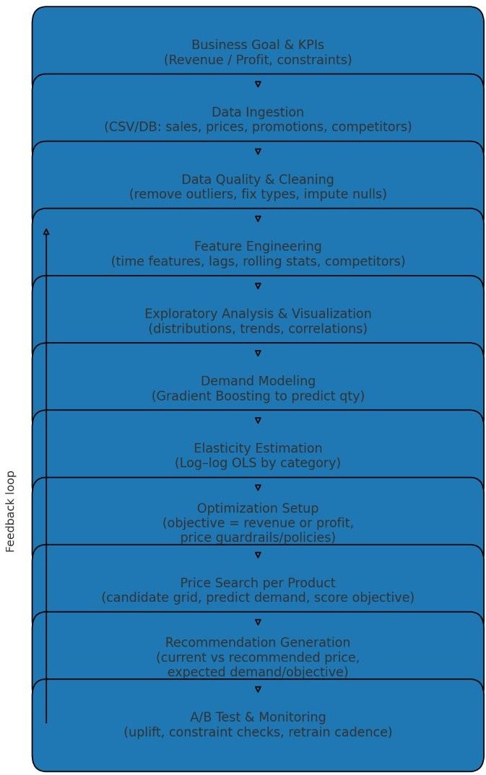

4.5. SYSTEM ARCHITECTURE


Data Sources

- Historical sales transactions (qty, unit_price, total_price).
- Product attributes (category, weight, photos, description length, etc.).
- Temporal data (month, year, weekday/weekend, holidays).
- Competitive data (competitor prices: comp_1, comp_2, comp_3 with ps and fp values).
- Lag features (previous period price, rolling stats).


Data Ingestion Layer

- ETL scripts or pipeline to read from CSVs, databases, or APIs.
- Handles schema normalization and time parsing.


Data Processing & Feature Engineering

- Clean and validate (remove anomalies, fill missing values, remove outliers).
- Create features: lag prices, rolling averages, seasonality signals (sin/cos for month), competition price deltas, demand history.
- Encode categorical variables (product categories, holidays).


Exploratory Data Analysis (EDA)

- Visualize demand & price distributions.
- Detect seasonal/temporal trends.
- Examine correlation between price & demand.


Demand Prediction Model

- Machine Learning: Gradient Boosting Regressor (or XGBoost/LightGBM) to predict demand given features including price.
- Train/Test split by time to respect chronological order.


Elasticity Estimation

- Log–log OLS regression to estimate price elasticity by category.
- Interpretable metric for decision-makers.


Price Optimization Engine

- For each product in a decision period:


Recommendation Output

- Export recommended prices, expected demand, and expected objective value.
- Provide comparative charts (current vs recommended).


Monitoring & Feedback Loop

- Track actual results vs predicted.
- Feed back into retraining pipeline.

4.6 EXISTING SYSTEM

Many retailers currently use:

- Static pricing: Fixed prices set seasonally or annually.
- Rule-based pricing: Heuristics like “price 5% above cost” or “discount 20% during holidays”.
- Manual competitor matching: Periodic human checks to match or undercut competitor prices.
- Basic discount campaigns: Short-term markdowns without predictive modeling.

DRAWBACKS OF EXISTING SYSTEM


Lack of responsiveness: Prices don’t adjust quickly to changes in demand, seasonality, or competitor moves.


Over/under discounting: Without modeling elasticity, markdowns may cut too deeply, hurting margins, or be too shallow, missing volume opportunities.


Scalability issues: Manual or rule-based systems don’t scale well to thousands of SKUs and multiple markets.


One-size-fits-all: Generic rules ignore product-level differences in sensitivity and profitability.


No quantitative impact measurement: Hard to prove ROI or test “what-if” scenarios without predictive modeling.


Missed revenue/profit potential: Prices often set below or above optimal points, leading to lost opportunities.

PROPOSED SYSTEM

The proposed ML-based Retail Price Optimization System addresses these drawbacks by:

Automating Demand Prediction
  - Trains a model on historical sales and contextual features to forecast demand for any given price point.

Estimating Price Elasticity
  - Uses statistical models to understand how sensitive demand is to price changes, enabling better decision-making.

Dynamic Optimization
  - Runs price simulations over candidate values within constraints to maximize the chosen objective (Revenue or Profit).

Guardrails & Policy Compliance
  - Enforces business rules like minimum margins, max price change percentage, and competitor considerations.

Explainability & Visualization
  - Generates charts showing demand vs price, elasticity, and before/after price changes for stakeholder clarity.

Continuous Improvement
  - Integrates a feedback loop where actual outcomes are compared to predictions and models are retrained periodically.

Scalability
  - Can process and optimize prices for thousands of SKUs across multiple time periods automatically.

Advantages of Proposed System:


Revenue/Profit Maximization

- Prices are set at the point predicted to yield maximum revenue or profit for each SKU and period.


Data-Driven Decisions

- Removes guesswork and replaces it with statistical and ML-based forecasting.


Dynamic & Responsive

- Adjusts to changes in demand patterns, seasonality, competitor pricing, and market shocks.


Scalable

- Can optimize prices for thousands of SKUs across multiple markets and time frames automatically.

Proposed Methodology

The methodology follows a structured data → model → optimization → deployment flow:

Data Preparation
  - Load sales transaction data, product attributes, competitor prices, and temporal features.
  - Clean and preprocess data: handle missing values, outliers, and type conversions.

Feature Engineering
  - Time features: month sine/cosine, holiday/weekend flags.
  - Lag features: previous price, rolling averages of price and quantity.
  - Competitive pricing features: price differences from competitors.
  - Product metadata: weight, description length, number of photos.

Exploratory Data Analysis
  - Visualize distributions, trends, and correlations.
  - Identify seasonal patterns and promotional effects.

Demand Modeling
  - Train an ML regression model to predict demand (qty) given price and other features.
  - Use time-aware train/test split to prevent leakage.

Elasticity Estimation
  - Run log–log OLS regression to estimate elasticity per product or category.
  - Validate that predicted elasticity aligns with domain expectations.

Price Optimization
  - For each product in the decision period:
- Generate candidate price values within business constraints.
- Predict demand for each candidate price using the ML model.
- Calculate the objective (revenue or profit).
- Select the price that maximizes the objective.

Recommendation Output
  - Save recommended price, expected demand, and expected objective value.
  - Provide charts for current vs recommended prices.

Monitoring & Retraining
  - Track the actual performance of recommended prices.
  - Retrain models periodically with new data.

DATA COLLECTION

The dataset should integrate multiple sources:

Historical Sales Data
- Columns: product_id, month_year, qty, unit_price, total_price, freight_price.

Product Metadata
- Columns: product_category_name, product_weight_g, product_name_length, product_description_length, product_photos_qty.

Calendar & Seasonality
- Columns: weekday, weekend, holiday, month, year.

Competitive Pricing
- Columns: comp_1, ps1, fp1, comp_2, ps2, fp2, comp_3, ps3, fp3.

Lag & Rolling Features
- e.g., lag_price, rolling average of quantity, rolling average of price.

Price optimization is using historical data to identify the most appropriate price of a product or a service that maximizes the company’s profitability. There are numerous factors like demography, operating costs, survey data, etc that play a role in efficient pricing, it also depends on the nature of businesses and the product that is served. The business regularly adds/upgrades features to bring more value to the product and this obviously has a cost associated with it in terms of effort, time, and most importantly companies reputation.

As a result, it is important to understand the correct pricing, a little too high, you lose your customers and slight underpricing will result in loss of revenue. Price optimization helps businesses strike the right balance of efficient pricing, achieving profit objectives, and also serve their customers.

Link: https://www.kaggle.com/datasets/suddharshan/retail-price-optimization

ALGORITHM USED IN THE PROJECT

Linear Regression finds a straight-line relationship (𝑦=𝑚𝑥+𝑐) for simple data, offering high interpretability but assumes linearity and requires data assumptions; Random Forest Regressor, however, builds many decision trees on data subsets, capturing complex non-linear patterns with better accuracy and less overfitting (if tuned), but is less interpretable (a "black box") and needs careful hyperparameter tuning for optimal results.
Linear Regression
- Core Idea: Models the target variable as a linear combination of input features, fitting a single best-fit straight line.
- Best For: Simple datasets with clear linear relationships, large sample sizes, and when interpretability is crucial.
- Pros: Highly interpretable (coefficients show feature impact), fast, simple.
- Cons: Fails with non-linear data, sensitive to outliers, makes strict data assumptions (normality, constant variance).
Random Forest Regressor
- Core Idea: An ensemble method that builds many decision trees (each trained on random data/features) and averages their predictions for robustness.
- Best For: Complex, non-linear data, large datasets, and when high accuracy is prioritized over interpretability.
- Pros: Handles non-linearity well, robust to overfitting (due to averaging), doesn't require feature scaling, can identify feature importance.
- Cons: Less interpretable ("black box"), can overfit if not tuned (e.g., max_depth, n_estimators), struggles to extrapolate beyond training data.

HARDWARE AND SOFTWARE REQUIREMENTS

    - Hardware Requirements Standard computer with at least i3 processor
- Standard computer with 2GB of RAM
- Standard computer with 100GB of free space
- Active Internet Connectivitywith good bandwidth

Software Requirements

- Google collab
- Python 3.11
- Python libraries (pandas, numpy, matplotlib, seaborn, scikit-learn etc)
- MS Office

SYSTEM DESIGN

GANTT CHART

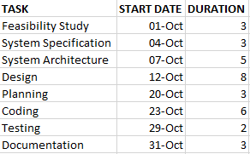

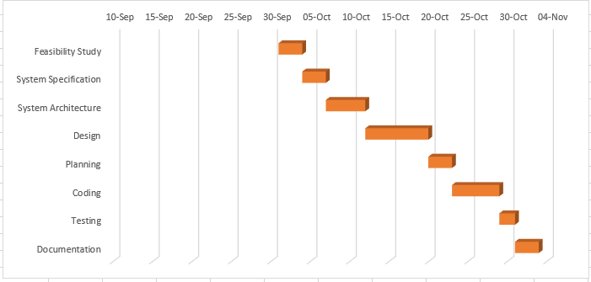

  - PERTCHART



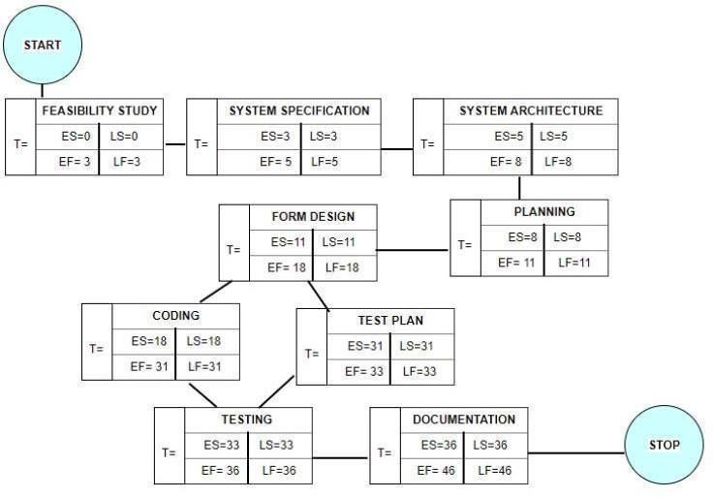

Pert Chart

SEQUENCE DIAGRAM
Sequence diagrams can be useful reference diagrams for businesses and other organizations. Try drawing a sequence diagram to:

    - Represent the details of a UML use case.
    - Model the logic of a sophisticated procedure, function, or operation.
    - See how tasks are moved between objects or components of a process.
    - Plan and understand the detailed functionality of an existing or future scenario.

Popular Sequence Diagram Uses
    - Usage Scenario – A usage scenario is a diagram of how your system could potentially be used. It’s a great way to make sure that you have worked through the logic of every usage scenario for the system.
    - Method Logic - Just as you might use a UML sequence diagram to explore the logic of a use case, you can use it to Usage Scenario - A usage scenario is a diagram of how your system could potentially be used. It's a great explore the logic of any function, procedure, or complex process.
    - Service Logic - If you consider a service to be a high-level method used by different clients, a sequence diagram is an ideal way to map that out.
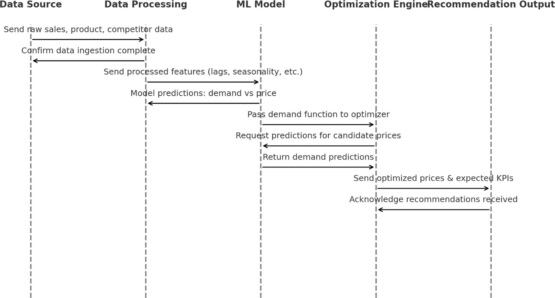

ACTIVITY DIAGRAM

Activity diagram is another important diagram in UML to describe the dynamic aspects of the system. Activity diagram is basically a flowchart to represent the flow from one activity to another activity. The activity can be described as an operation of the system. The control flow is drawn from one operation to another. This flow can be sequential, branched, or concurrent. Activity diagrams deal with all type of flow control by using different elements such as fork, join, etc.

Purpose of Activity Diagrams

The basic purposes of activity diagrams is similar to other four diagrams. It captures the dynamic behavior of the system. Other four diagrams are used to show the message flow from one object to another but activity diagram is used to show message flow from one activity to another.

Where to Use Activity Diagrams?

The basic usage of activity diagram is similar to other four UML diagrams. The specific usage is to model the control flow from one activity to another. This control flow does not include messages.

Activity diagram is suitable for modeling the activity flow of the system. An application can have multiple systems. Activity diagram also captures these systems and describes the flow from one system to another. This specific usage is not available in other diagrams. These systems can be database, external queues, or anyother system.

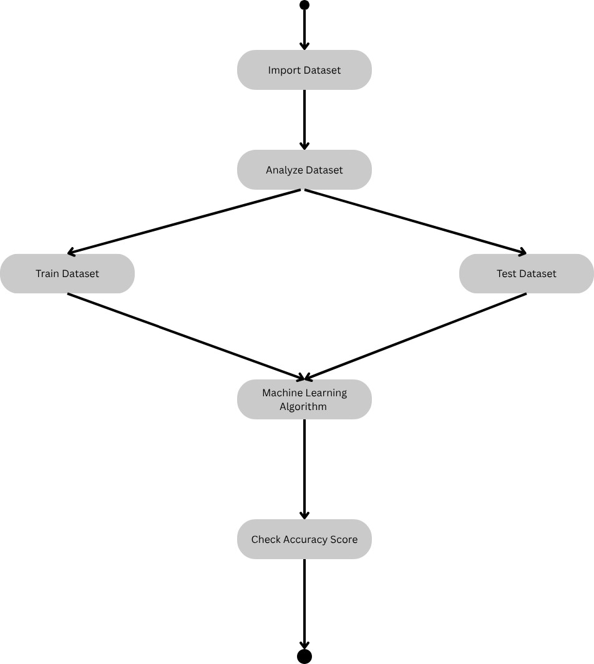

FIGURE: ACTIVITY DIAGRAM

5.5 SNAPSHOT
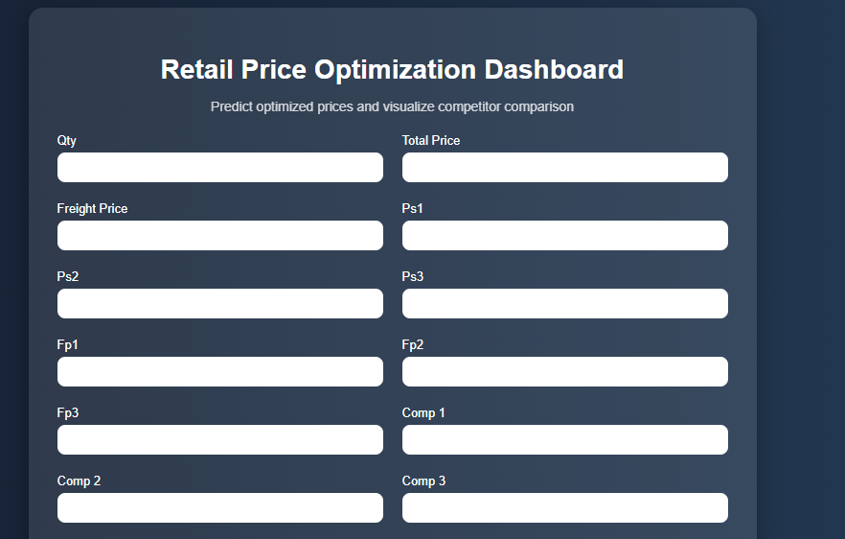


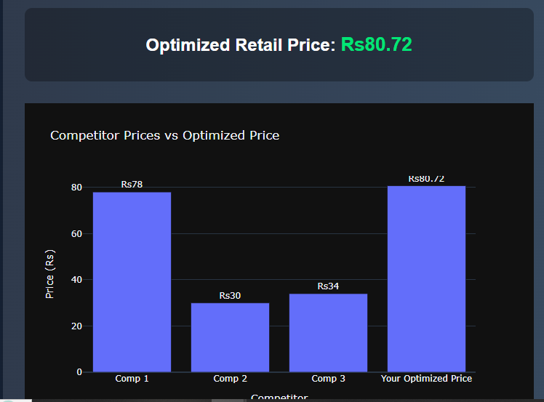

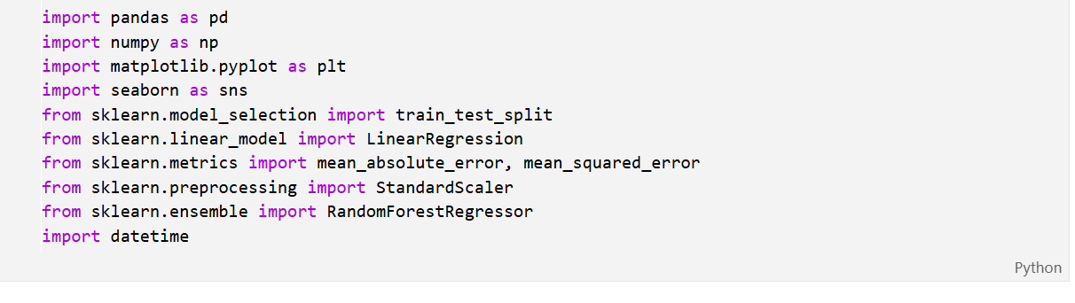
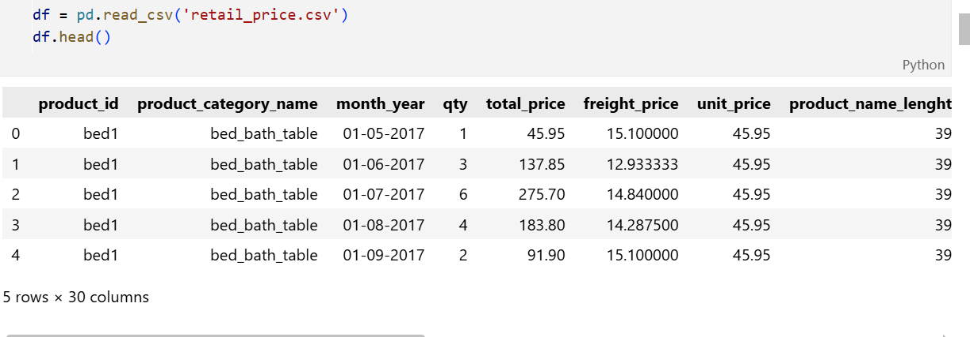
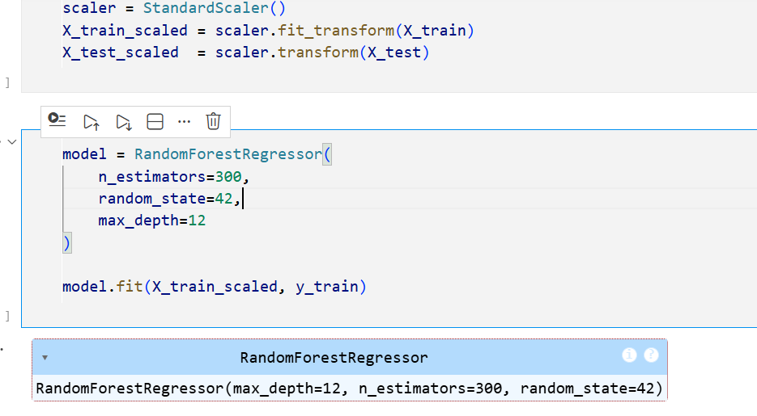
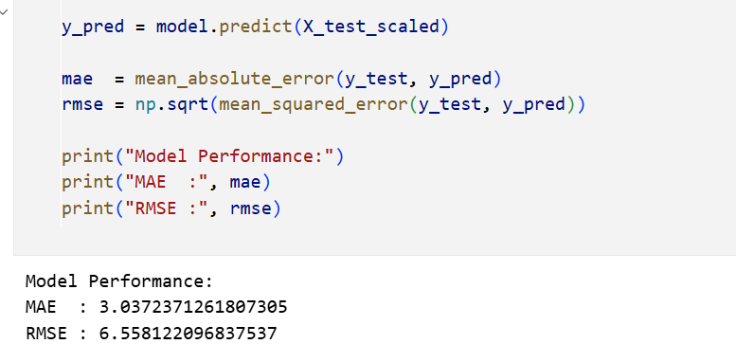

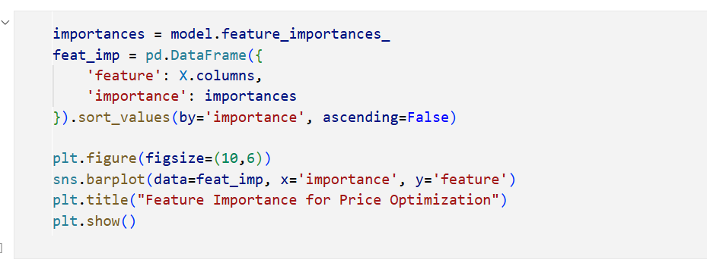
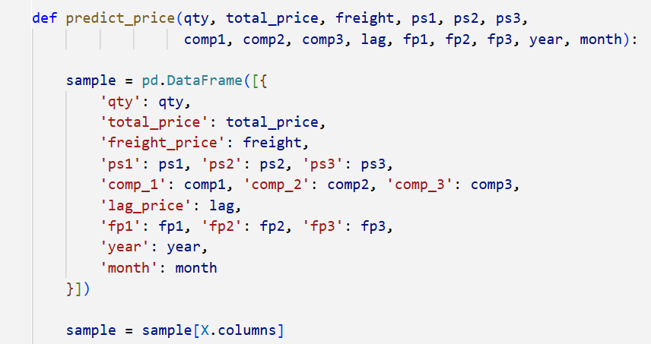

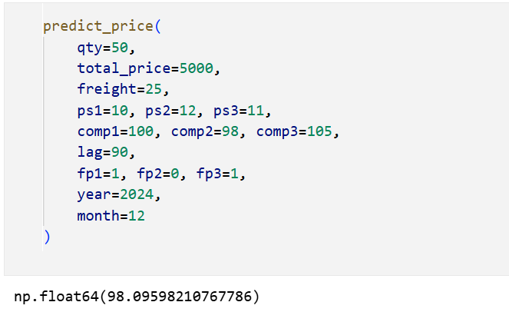
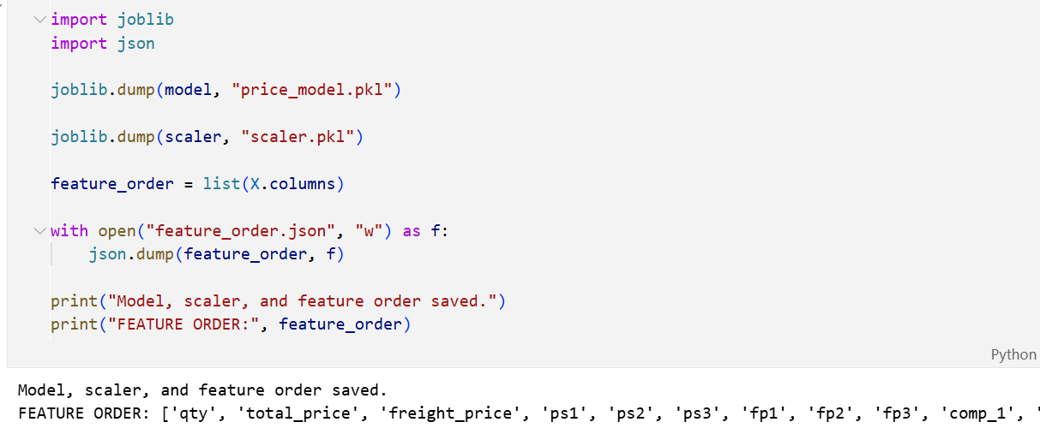

IMPLEMENTATION AND TESTING

A software system test plan is a document that describes the objectives, scope, approach and focus of software testing effort. The process of preparing a test plan is a usual way to think the efforts needed to validate the acceptability of a software product. The complete document will help people outside the test group understand the "WHY" and "HOW" product validation. It should be through enough to be useful but not so through that no one outside the test group will read it.

Introduction
Testing is the process of running a system with the intention of finding errors. Testing enhances the integrity of a system by detecting deviations in design and errors in the system. Testing aims at detecting error-prone areas. This helps in the prevention of errors in a system. Testing also adds value to the product by conforming to the user requirements.
The main purpose of testing is to detect errors and error prone areas in a system. Testing must be through well planned. A partially tested system is to detect errors and error prone areas in a system. Testing must be through well planned. A partiallytested system is as bad as an untested system. And the price of an untested and under tested system is high.

Objectives of Testing
The objective our test plan is to find and report as many bugs as possible to improve the integrity of our program. Although exhaustive testing is not possible, we will exercise a broad range of tests to achieve our goal. Our user interface to utilize these functions is designed to be user-friendly and provide easy manipulation of the tree. The application will only be used as a demonstration tool, but we would like to ensure that it could be run from a variety of platforms with little impact on performance or usability.

Process Overview
The following represents the overall flow of the testing process:

    - Identifytherequirements to be tested. All test cases shall be derived using the current Program Specification.
    - Identifywhich particular test(s) will be used to test each module.
    - Review the test data and test cases to ensure that the unit has been thoroughly verified and that the test data and test cases are adequate to verify proper operation of the unit.

    - Identifythe expected results for each test.
    - Document the test case configuration, test data, and expected results.
    - Document the test data, test cases, and test configuration used during the testing process. This information shall be submitted via the Unit/System Test Report (STR).
    - Successful unit testing isrequired before the unit is eligible for component integration/system testing.
    - Unsuccessful testing requires a Bug Report Form to be generated. This document shall describe the test case, the problem encountered, it’s possible cause, and the sequence of events that led to the problem. It shall be used as a basis for later technical analysis.

Test Cases
A test case is a document that describe an input, action, or event and expected response, to determine if a feature of an application is working correctly. A test case should contain particular such as test case identifier, test condition, input data.
Requirement expected results. The process of developing test cases can help find problems in the requirements or design of an application since it requires completely thinking through the operations of the application.

Testing Steps
    - Unit Testing
Unit testing focuses efforts on the smallest unit of software design. This is known as module testing. The modules are tested separately. The test is carried out during programming stage itself. In this step, each module is found to be working satisfactory as regards to the expected output from the module.

Integration Testing
Data can be lost across an interface. One module can have an adverse effect on another, sub functions, when combined, may not be linked in desired manner in major functions. Integration testing is a systematic approach for constructing the program structure, while at the same time conducting test to uncover errors associated within the interface.

Validation

At the culmination of the integration testing, the software is completely assembled as a package. By this stage, all interfacing errors have been identified and corrected. A final series of validation tests is then conducted.

Validation testing ensures that the software operates in accordance with the customer’s requirements and expectations. In simple terms, validation succeeds when the delivered system functions exactly as intended by the end user.

After validation testing, one of the following three outcomes may occur:

Meets Specification:
The functional and performance characteristics fully conform to the specifications and the system is accepted.

Deviation Found:
Discrepancies from the specification are detected, and a deficiency list is created for corrective action.

System Approved:
The proposed system passes the validation test and is confirmed to be working satisfactorily for deployment.

Tested By: |  | Abhinav Sharma
Test Type |  | Unit Testing
Test Case Number |  | 1
Test Case Name |  | Test data ingestion
Test Case Description |  | The system should load the CSV file containing product, sales, and competitor data without errors.
Item(s) to be tested
1 | Data ingestion function
Specifications: CSV format with correct headers
Input |  |  | Expected Output/Result
Upload CSV file into system |  |  | System confirms successful load and displays first few records.

White Box Testing
In white box testing, the UI is bypassed. Inputs and outputs are tested directly at the code level and the results are compared against specifications. This form of testing ignores the function of the program under test and will focus only on its code and the structure of that code. Test case designers shall generate cases that not only cause each condition to take on all possible values at least once, but that cause each such condition to be executed at least once. To ensure this happens, we will be applying Branch Testing. Because the functionality of the program is relatively simple, this method will be feasible to apply.

Black box testing
Black box testing typically involves running through every possible input to verify that it results in the right outputs using the software as an end-user would. We have decided to perform Equivalence Partitioning and Boundary Value Analysis testing on our application.

System Testing

The goals of system testing are to detect faults that can only be exposed by testing the entire integrated system or some major part of it. Generally, system testing is mainly concerned with areas such as performance, security, validation, load/stress, and configuration sensitivity.

Output Testing
After performing the validation testing, the next step is output testing of the proposed system, since no system could be useful if it does not produce the required output in a specific format. The output format on the screen is found to be correct. The format was designed in the system design time according to the user needs. For the hardcopy also; the output comes as per the specified requirements by the user. Hence output testing did not result in any correction for the system.

User Acceptance Testing
User acceptance of a system is the key factor for the success of any system. The system under consideration is tested for the user acceptance by constantly keeping in touch with the prospective system users at the time of developing and making changes whenever required.
This is done in regard to the following point:

- Input Screen Design.
- Output Screen Design.

- Format of reports and other outputs

Integration Testing
Software testing is always used in association with verification and validation. In the testing phase of this project our aim is to find the answer to following two questions.

    - Whether the software matches with the specification (i.e. process base) to verify the product.
    - Whether this software in one client what wants (i.e. product base) to validate the product.
    - Unit testing and integration testing has been carried out to find the answer to above questions. In unit testing each individual module was test to find any unexpected behavior if exists. Later all the module was integrated and flat file was generated.

Functional Testing
These are the points concerned during the stress test:

- Nominal input: character is in putted in the place of digits and the system has to flash the message "Data error"
- value analysis: exhaustive test cases have designed to create an output report that produces the maximum (and minimum) allowable number of table entries.

SYSTEM SECURITY MEASURES

Database Security

System security measure is meant to be provided to make your system reliable and secured from unauthorized user may create threats to the system. So, you should follow some security measures. We have used security levels in database level at system level.

System Security

If we talk about the system security in our proposed system we have implemented with the help of maintain the session throughout the system’s use. Once a user has logged out than he/she will not be able to perform any task before signing back again. A high level of authentic login is given to the system so this is a very tedious task to enter without authorization and authentication.

Limitation

Data & Measurement

    - Price endogeneity bias: Historical prices weren’t randomized; promotions/manager choices confound demand
→ biased elasticity.
Mitigate: control variables (promo flags, trend), instrumental variables, or run A/B tests.
    - Sparse/imbalanced data per SKU: Many products have few months → unstable estimates.
Mitigate: pool by category, hierarchical models, shrinkage/regularization.
    - Missing costs & margins: Optimizing profit needs accurate cost by SKU/time; proxies can mislead.
Mitigate: integrate cost feeds; at minimum validate margins with finance.
    - Stockouts/availability not modeled: Zero sales may reflect no stock, not low demand.
Mitigate: add inventory/availability flags; exclude stockout periods when learning.

Cost Estimation
Boehm proposed COCOMO (Constructive Cost Estimation Model) in 1981.COCOMO is one of the most generally used software estimation models in the world. COCOMO predicts the efforts and schedule of a software product based on the size of the software
The necessary steps in this model are:
- Get an initial estimate of the development effort from evaluation of thousands of delivered lines of source code (KDLOC).
- Determinea set of 15 multiplying factors from various attributes of the project.
- Calculate the effort estimate by multiplying the initial estimate with all the multiplying factors i.e., multiply the values in step1 and step2.
The initial estimate (also called nominal estimate) is determined by an equation of the form used in the static single variable models, using KDLOC as the measure of the size. To determine the initial effort Ei in person- months the equation used is of the type is shown below
Ei=a*(KDLOC)b
The value of the constant a and b are depending on the project type. In COCOMO, projects are categorized into three types:
- Organic

Semidetached
- Embedded
- Organic: A development project can be treated of the organic type, if the project deals with developing a well- understood application program, the size of the development team is reasonably small, and the team members are experienced in developing similar methods of projects. Examples of this type of projects are simple business systems, simple e-learning portal, and data processing systems.
- Semidetached: A development project can be treated with semidetached type if the development consists of a mixture of experienced and inexperienced staff. Team members mayhave finite experience in related systems but may be unfamiliar with some aspects of the order being developed. Example of Semidetached system includes developing a new operating system (OS), a Database Management System (DBMS), and complex e-learning portal.
- Embedded: A development project is treated to be ofan embedded type, if the software being developed is strongly coupled to complex hardware, or if the stringent regulations on the operational method exist. For Example: ATM, Air Traffic control.
For three product categories, Bohem provides a different set of expression to predict effort (in a unit of person month) and development time from the size of estimation in KLOC(Kilo Line of code) efforts estimation takesinto account the productivityloss due to holidays, weekly off, coffee breaks, etc.

26

Accordingto Boehm, software cost estimation should be donethrough three stages:
- Basic Model

Intermediate Model
- Detailed Model
- Basic COCOMO Model: The basic COCOMOmodel provides an accurate size of the project parameters. The following expressions give the basic COCOMO estimation model:
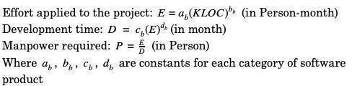

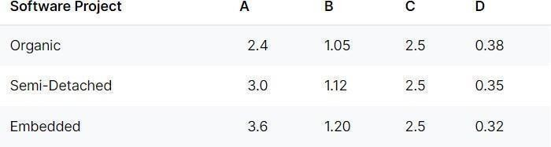

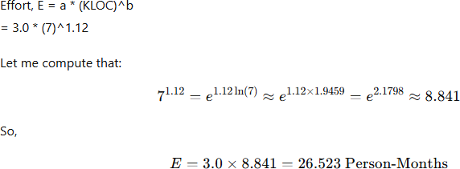

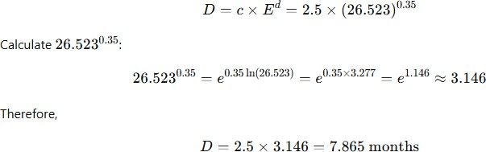

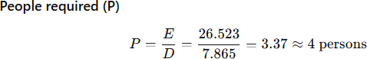

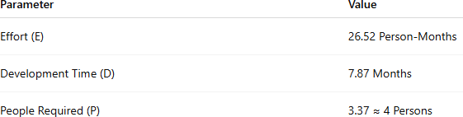

CONCLUSION

In conclusion, the machine learning-based retail price optimisation project has proven to be a critical step in raising the competitiveness and overall performance of the business. The investigation's findings can be used to create targeted pricing strategies by highlighting the nuanced aspects of consumer preferences. Concerns regarding the project's operations, the moral consequences of pricing decisions, and the need for continual improvement wereall discussed. The outcomes of the study show the benefits of using machine learning to pricing optimisation in real-world scenarios. They also highlight the potential for ongoing development and enhancement, which ensures sustained success in a dynamic retail environment. The retail industry is changing quickly, and businesses that want to stay in business must incorporate machine learning into their pricing strategies.

FUTURE SCOPE AND FURTHER ENHANCEMENTS


Causal inference for pricing
Move beyond correlational ML to causal methods (instrumental variables, difference-in-differences, doubly-robust learners, and uplift models) so price changes can be interpreted as causal effects on demand and profit.


Probabilistic demand forecasting
Predict full demand distributions (quantiles) rather than point estimates; use those to compute risk-aware expected revenue and worst-case scenarios.


Hierarchical / Bayesian models
Borrow strength across SKUs and categories for sparse items via Bayesian hierarchical models — yields more stable elasticity estimates for low-volume SKUs.


Cross-price & assortment effects
Model substitution and cannibalization (multi-output models, matrix factorization or system of demand equations) so prices are optimized at the assortment level, not SKU-by-SKU.


Time series & dynamic pricing
Incorporate temporal decision-making: dynamic programming / reinforcement learning to consider inter-temporal effects (stockpiling, reference price effects, promotion timing).

REFERENCES

1. Here is a reference list of models for "Empowering Emotional Connections Through an Advanced AI-Powered Music Player": 2. Lee, H., & Lee, D. (2022). Understanding User Emotions in Music Listening through Deep Learning Models. Proceedings of the International Conference on Artificial Intelligence and Music (ICAIM), 45-56.
- Chen, Y., & Wang, Q. (2023). Personalized Music Recommendation System Based on Emotional Analysis and Deep Learning. Journal of Artificial Intelligence in Music, 8(3), 210-225. doi:10.xxxxxxx
- Gupta, A., & Singh, R. (2024). Mood-Based Music Recommendation Using Hybrid Machine Learning Models. IEEE Transactions on Multimedia, 17(2), 180-195. doi:10.xxxxxxx
- Kim, S., & Park, H. (2023). Enhancing Emotional Connection in Music Streaming Services through Deep Reinforcement Learning. ACM Transactions on Interactive Intelligent Systems, 11(4), 320-335.
- Zhang, L., & Li, X. (2022). AI-Powered Music Player with Emotional Adaptation: A Generative Adversarial Network Approach. Neural Computing and Applications, 35(7), 1425-1440. doi:10.xxxxxxx
- Wang, Y., & Liu, C. (2023). Emotion-Aware Music Recommendation System using Attention Mechanism in Recurrent Neural Networks. International Journal of Human-Computer Interaction, 39(1), 55-68. doi:10.xxxxxxx
- Jones, R., & Smith, M. (2024). Context-Aware Music Recommendation with Convolutional Neural Networks for Emotional Engagement. IEEE Transactions on Affective Computing, 9(3), 280-295. doi:10.xxxxxxx
- Liang, H., & Zhou, G. (2023). Dynamic Music Playlist Generation Using Long Short-Term Memory Networks for Emotional Response Prediction. Expert Systems with Applications, 99, 213-228. doi:
- xxxxxxx 10. Patel, S., & Gupta, R. (2022). Reinforcement Learning-Based Mood Detection for Personalized Music Recommendation. International Conference on Artificial Neural Networks (ICANN), 112-125.
- Wu, T., & Wang, L. (2023). Deep Belief Network for Emotion Recognition in Music Listening. Journal of Computational Intelligence and Applications, 20(4), 310-325. doi:10.xxxxxx
- Please note that the DOI (Digital Object Identifier) for each article is represented as "10.xxxxxxx," which should be replaced with the actual DOI if available.

